**NAME: AMAN AGRAWAL**

**ROLL NO: G24AIT172**

**SUB: ML**-**OPs**

**TASK : ASSIGNMENT-2 (Docker Fundamentals)**

Docker Repository: <https://hub.docker.com/repository/docker/aman007agg/docker-assignment-python-hello/general>

**1. Introduction:**

This report describes the process of setting up a custom Docker image containing a Python script. The script prints a message with my roll number **(G24AIT172)** when executed inside a container.

The goal is to pull an official Python image, customize it with a simple script, build a Docker image, and push it to Docker Hub.  
  
**2. Setup Process**

**2.1. Install Docker Desktop on Windows.**

Pre-requisite:

**(A.) Install WSL (Windows Subsystem for Linux)-WSL**

Search for WSL on your local system , and click run as administrator

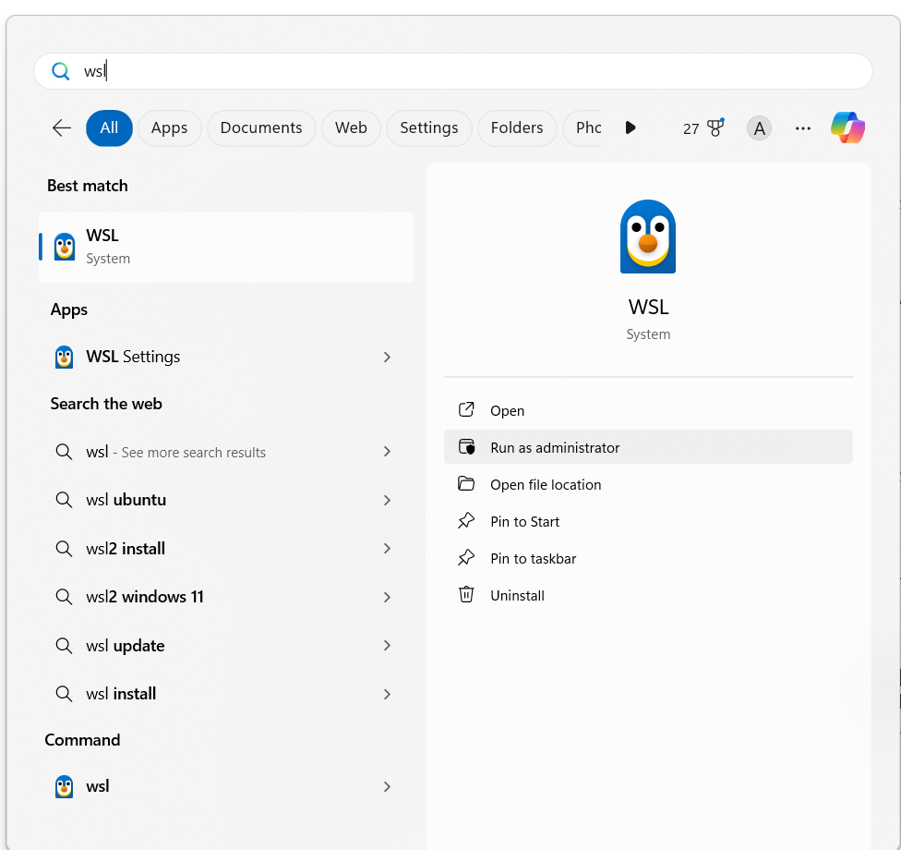

Run the command: **wsl.exe --install**

After it gets succesfully installed .  
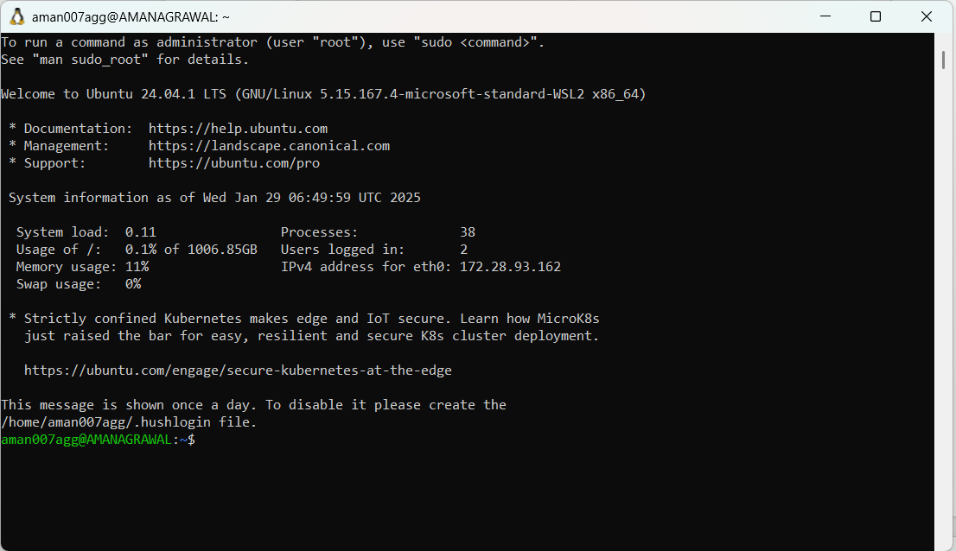

1. **) To set WSL2 as the default version for future installations:**

Run the command:  **wsl --set-default-version 2**

Kindly Note:   
When prompted to create a UNIX username during the WSL (Windows Subsystem for Linux) installation process, you simply need to:

1. Enter a preferred username. This username does not need to match your Windows username, but it will be your default username for logging into the WSL environment.
2. Press **Enter**.
3. You’ll then be asked to create a password for this user. Ensure the password is something you’ll remember, as it will be needed to authenticate commands requiring elevated privileges (via sudo).

**Enter new UNIX username:** yourusername

**New password:** ********

**Retype new password:** ********

1. **) To check the version of WSL you are using, you can run:**

Run the command: **wsl --list --verbose**

You can run the command on cmd as an administrator mode  
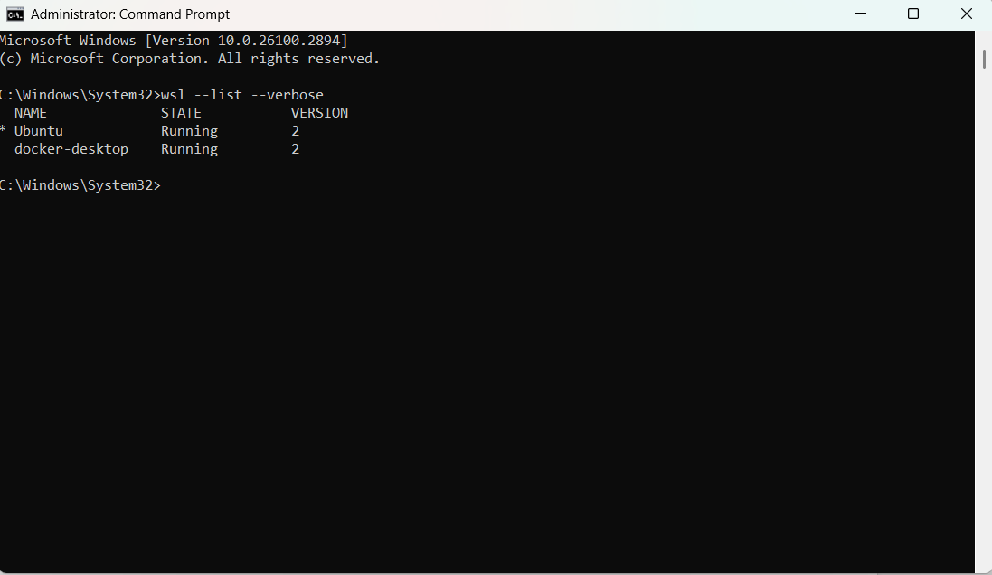

**(D.) You can check the system requirements before setting up the Docker Desktop for windows.**  
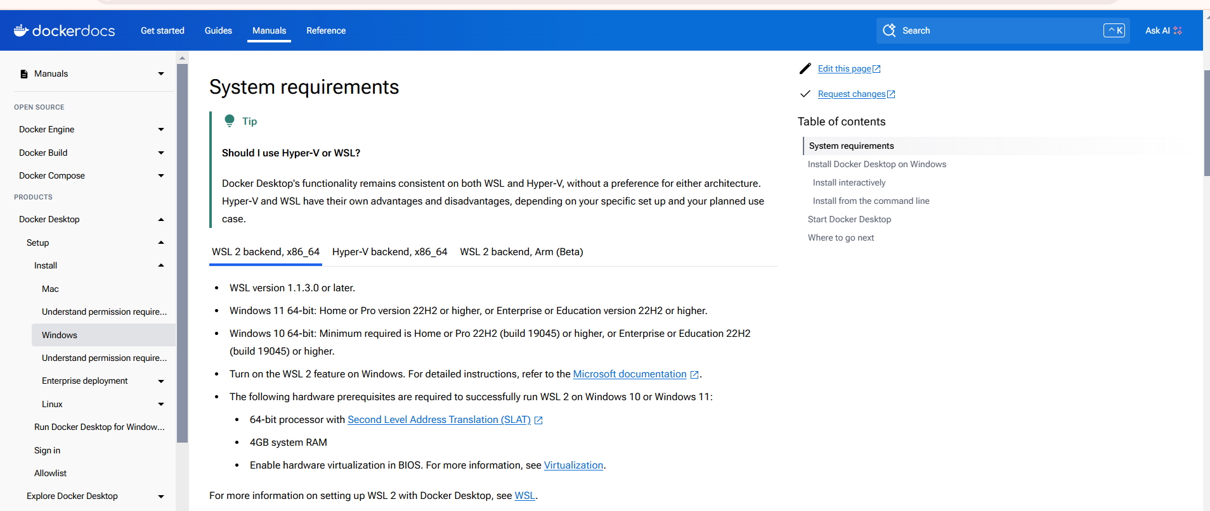

**(E.) Go to the specfied url and download the Docker Desktop on Windows**- <https://docs.docker.com/desktop/setup/install/windows-install/>  
  
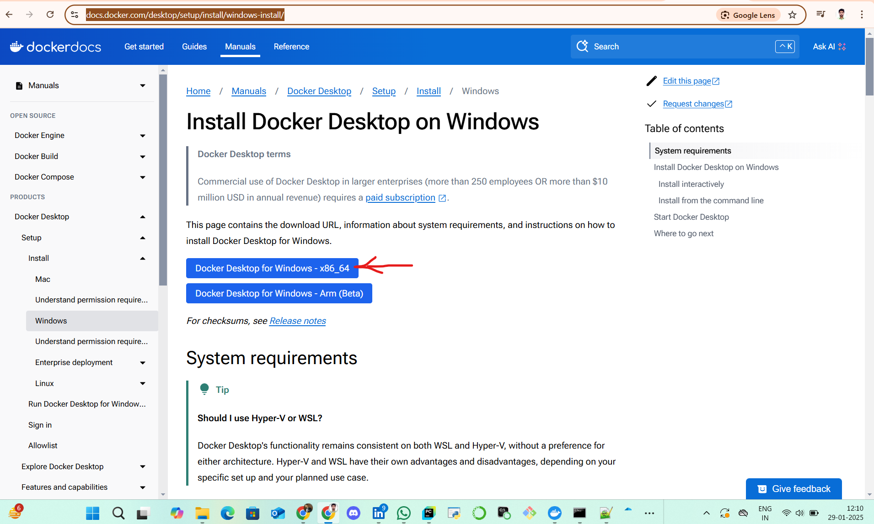

**(F.) Once it gets successfully installed, make sure that docker is in running mode.**

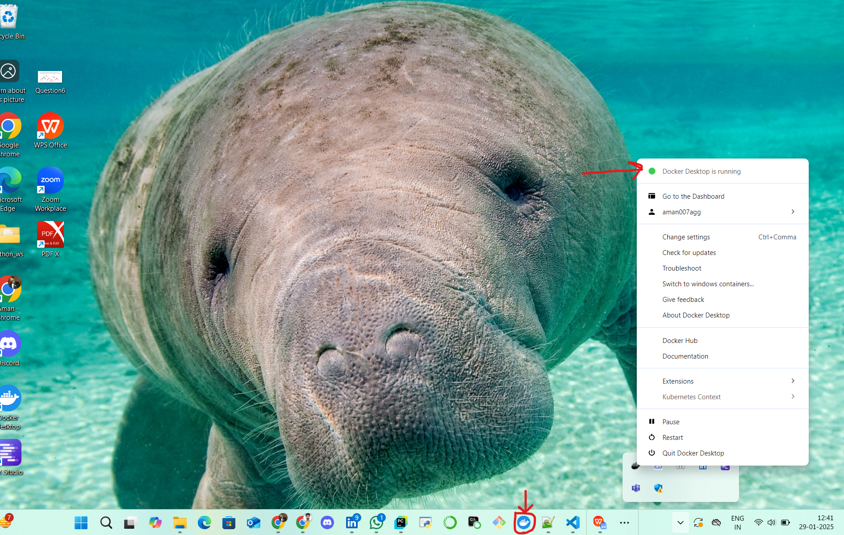

**(G.) Enable WSL 2 Integration in Docker:** During the installation, Docker Desktop will ask you to enable WSL 2 integration. Make sure that you check the option to use WSL 2 as the backend for Docker. Docker will automatically set this up for you.

* Once Docker Desktop is installed, open Docker Desktop from the Start menu.
* Go to **Settings** (gear icon) > **Resources** > **WSL Integration**.
* Ensure that **Enable integration with my default WSL distro** is checked. You can also enable integration with other WSL distributions if you have more than one.

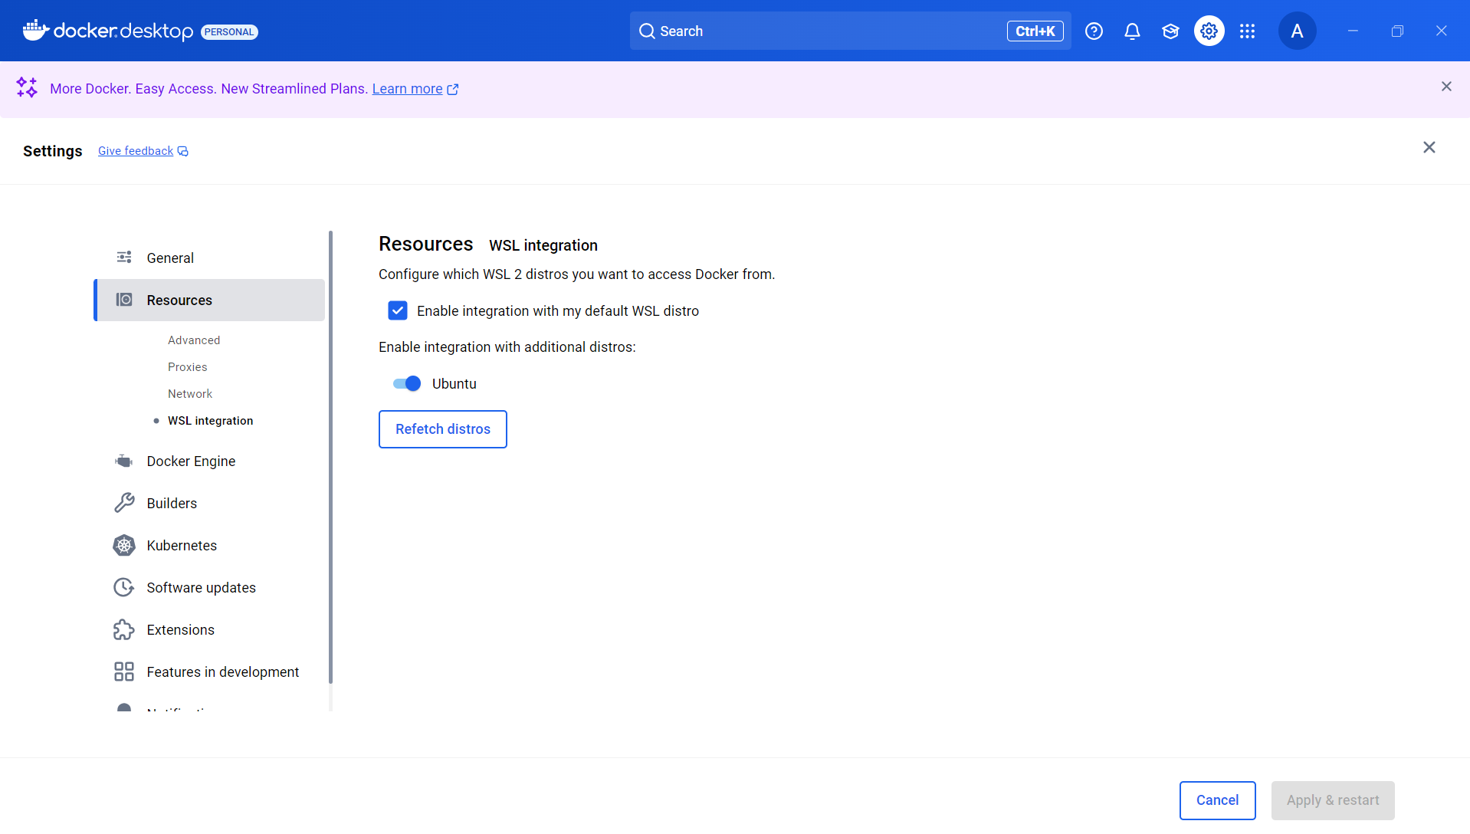

**(H.) Test Docker Installation:** Once Docker Desktop is running, open a command prompt or PowerShell window and run the following command to verify Docker is installed and running:

**docker --version**

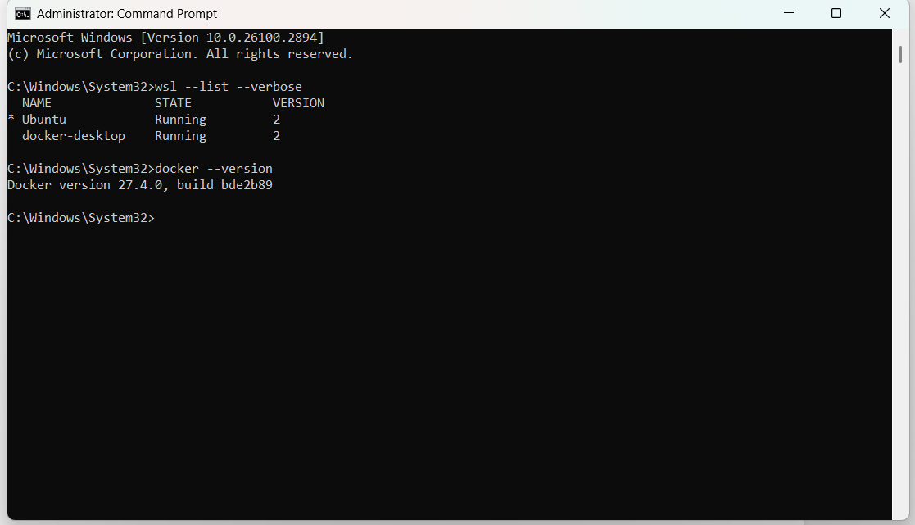

**3. Step-by-Step Execution**

**3.1 Create a new docker hub repository-**

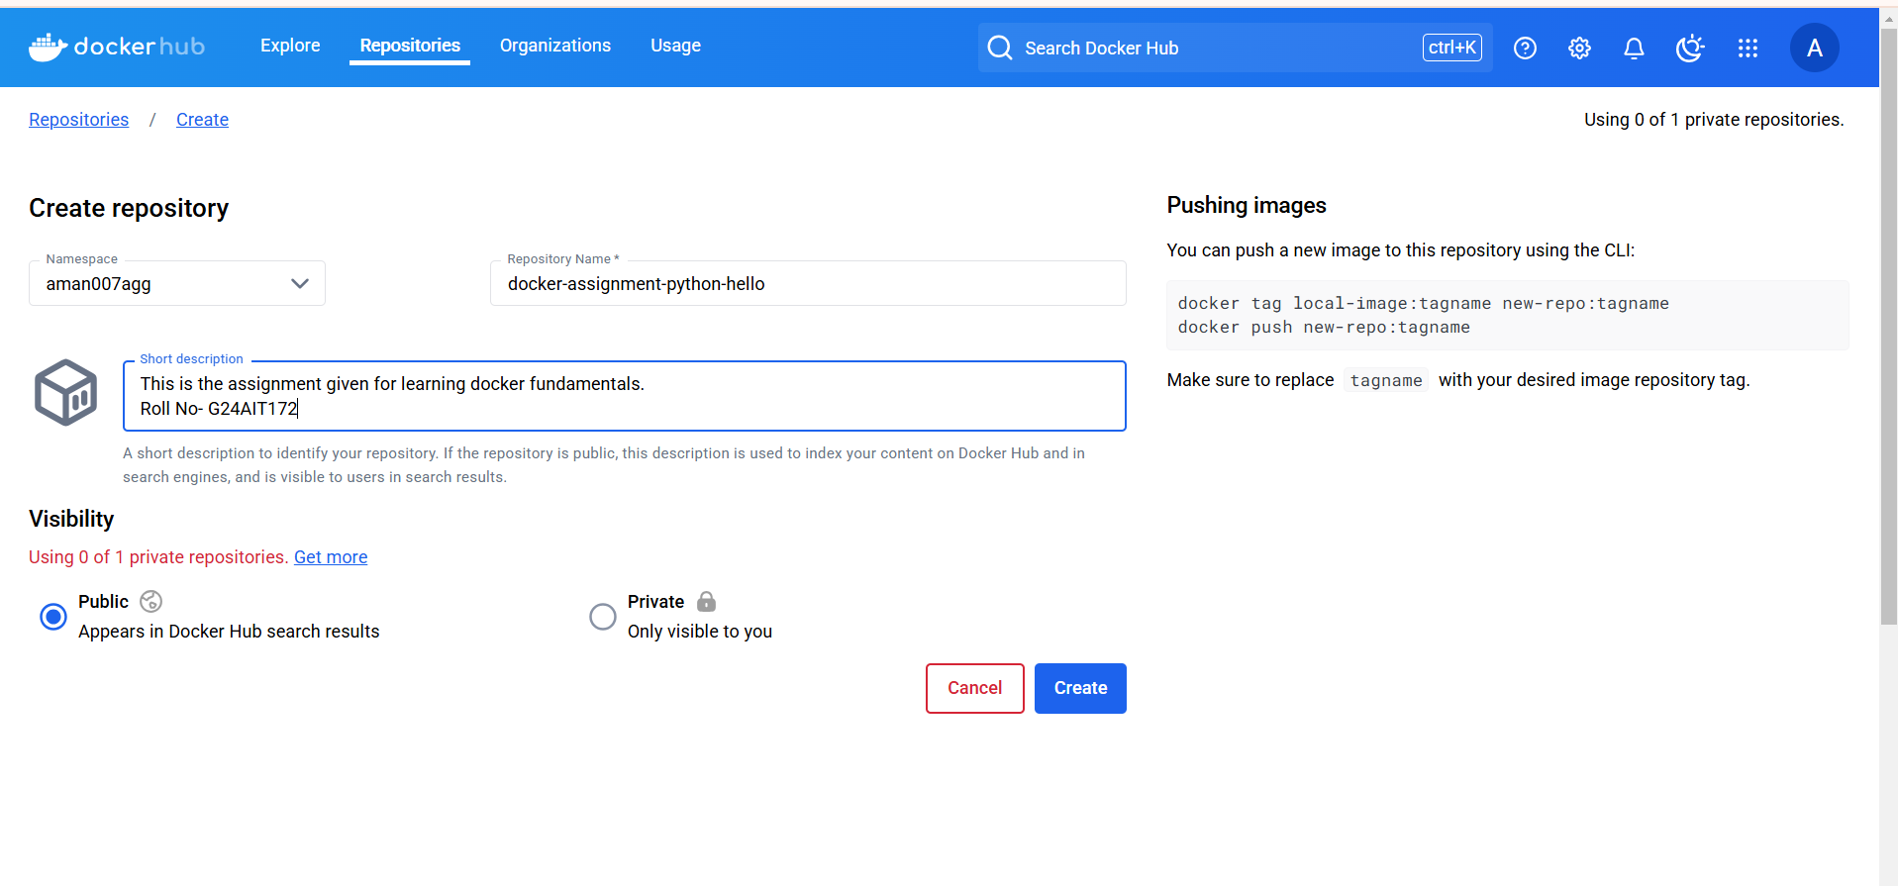

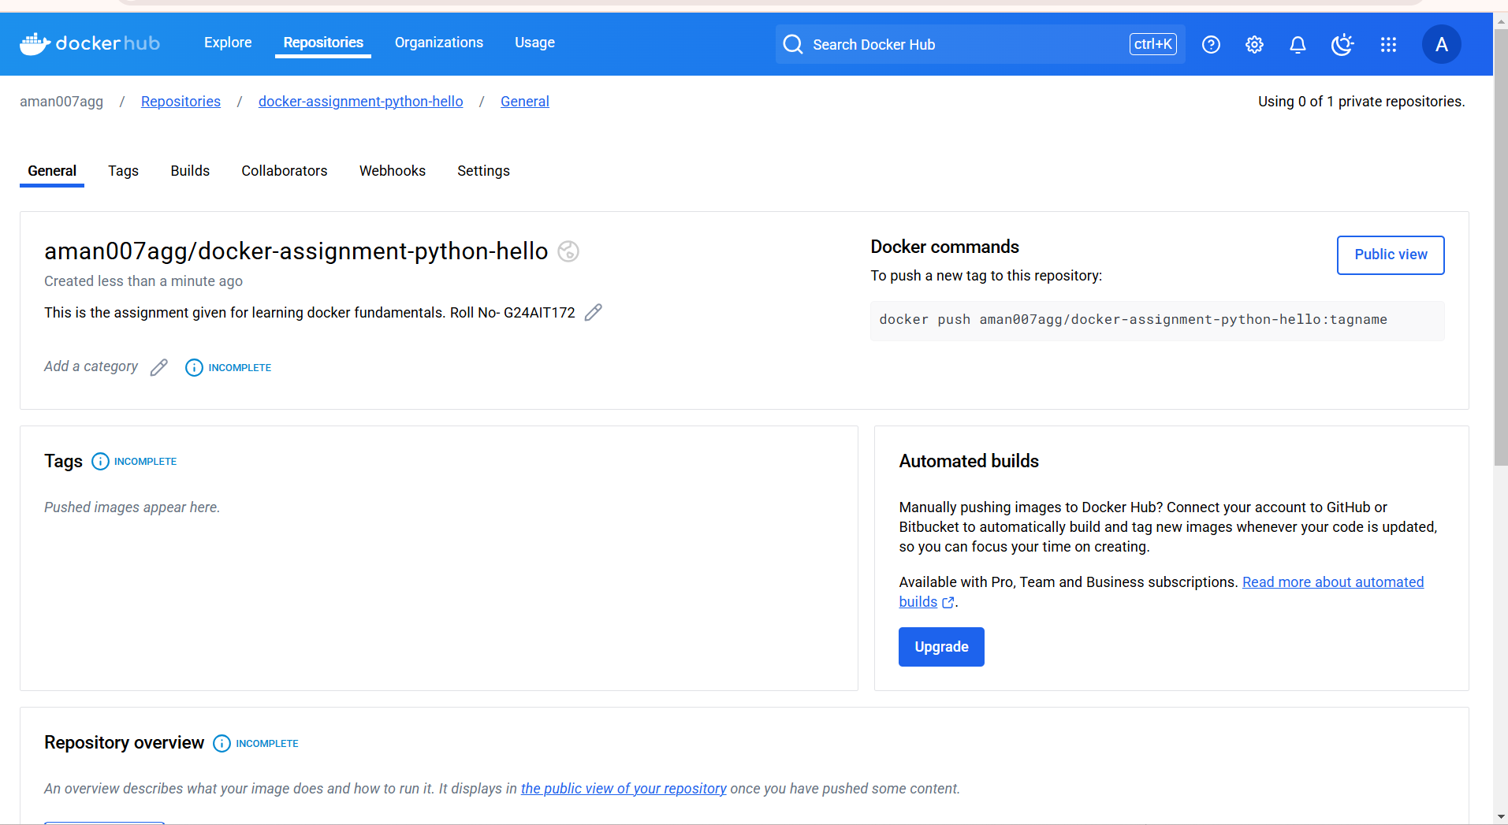  
  
Pull command - docker pull aman007agg/docker-assignment-python-hello

**A. Pull the official Python image, python:-alpine (the smallest version)**.

**docker pull python:3.11-alpine**

The Alpine version is chosen because it is a lightweight Linux distribution optimized for containers.

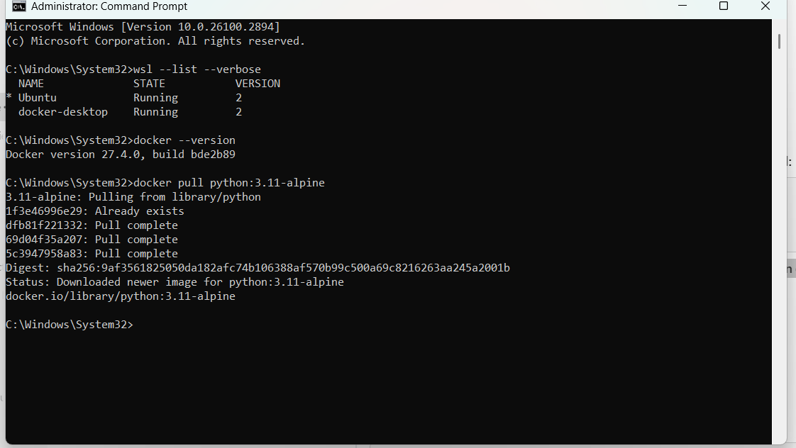  
  
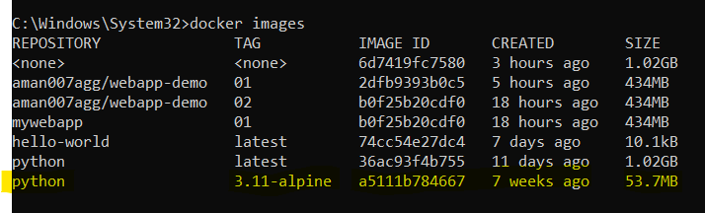

you can check on Docker Desktop as well

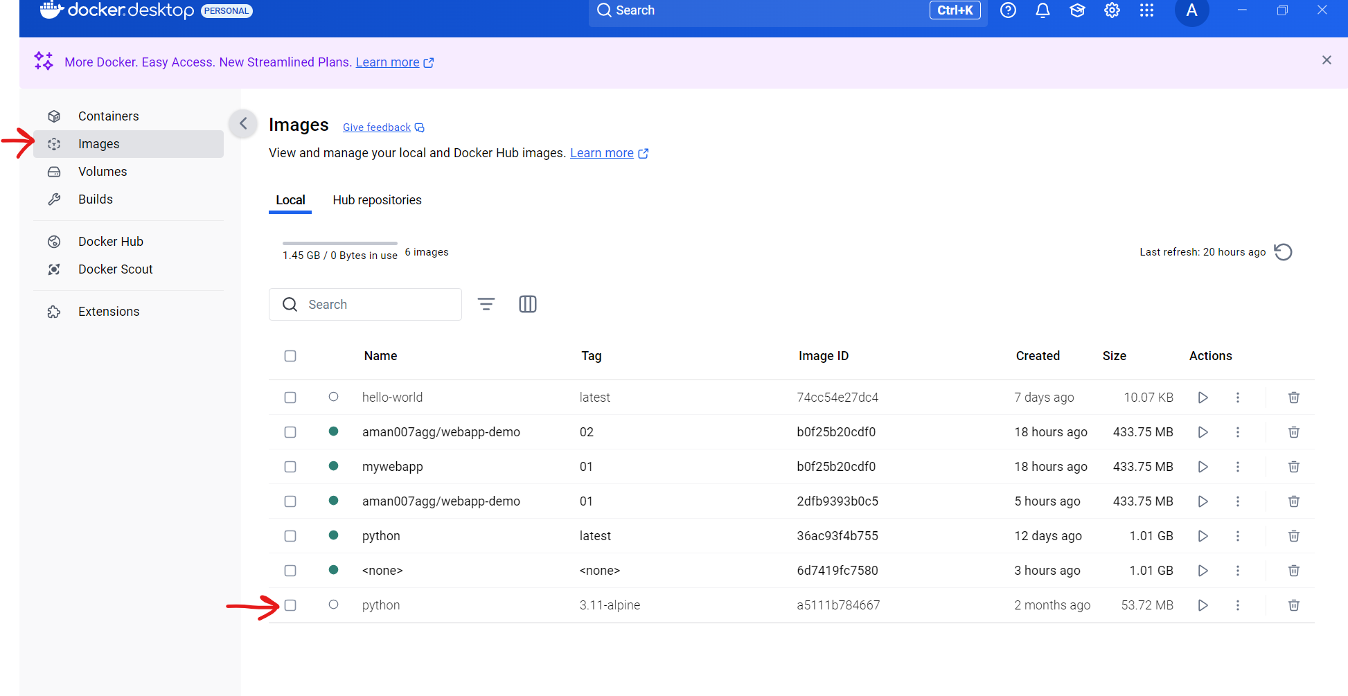

1. **Build a custom Docker image by creating a directory, and adding a hello.py file that prints "Hello from the container, Your Roll No.(replace this with your roll no.)". Use a Dockerfile to create the image.**

**1. Create a Directory -**

Have created a directory named - **“docker-assignment”**

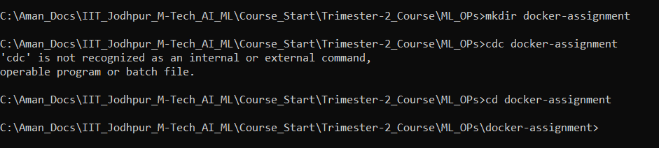

Note : I am using Pycharm to create custom Docker Image

**2. Create a hello.py (python) file-**

So , first I am creating a python file - **hello.py** with the following content:

**"Hello from the container,G24AIT172”**

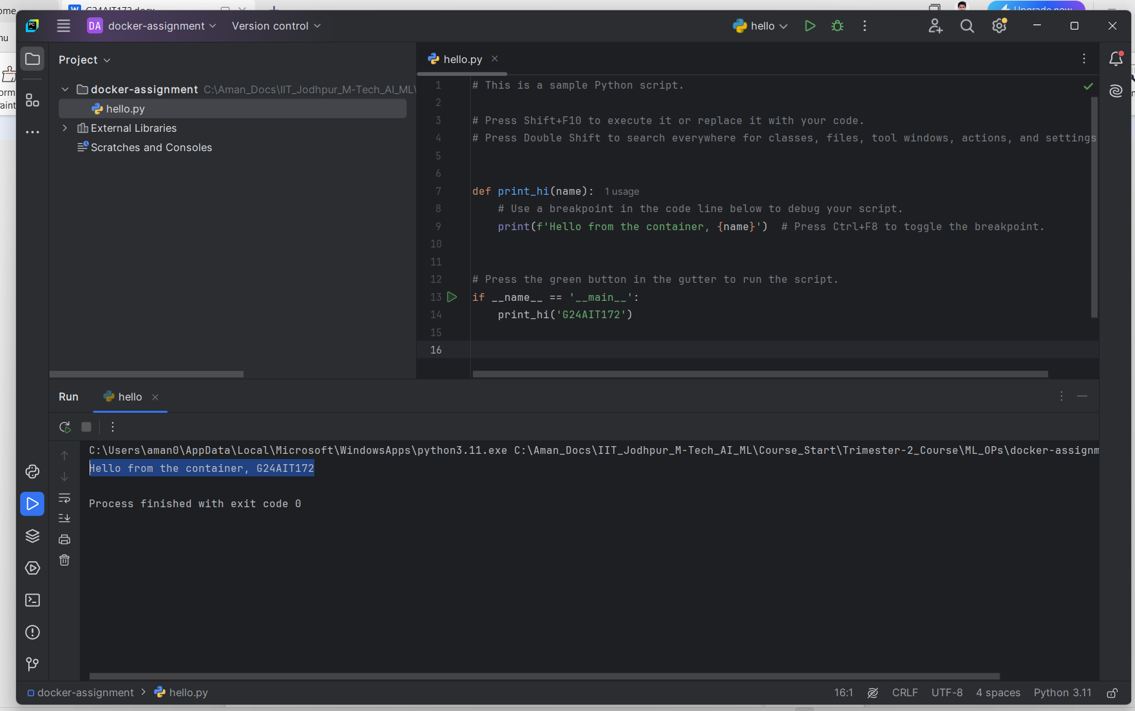

**3. Now creating a Dockerfile**

**# Use the official Python Alpine image**

**FROM python:3.11-alpine**

**# Set the working directory inside the container**

**WORKDIR /myapp**

**# Copy hello.py into the container**

**COPY hello.py .**

**# Command to run the Python script**

**CMD ["python", "hello.py"]**

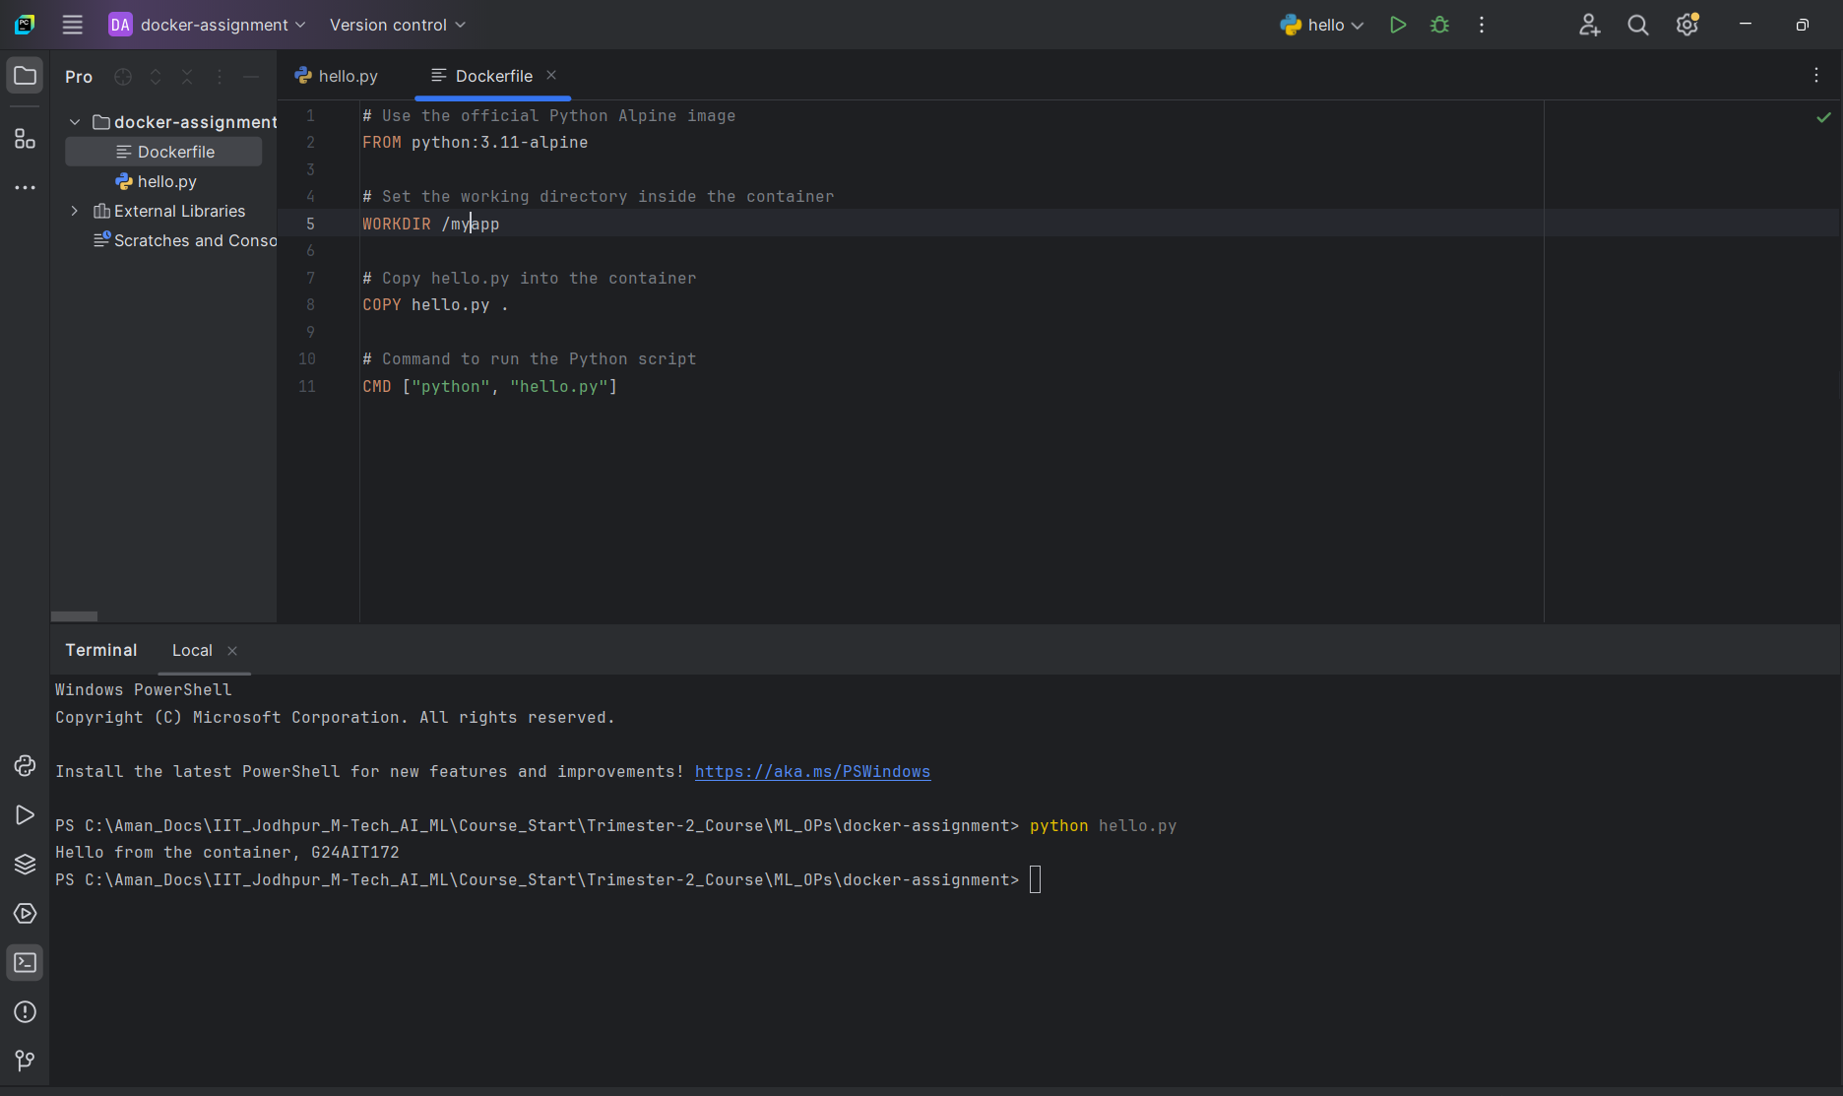

·  **FROM python:3.11-alpine:** Specifies the base image.

· **WORKDIR /myapp:** Sets the working directory inside the container.

· **COPY hello.py .:** Copies the script into the container.

· **CMD ["python", "hello.py"]:** Runs the script when the container starts.

**4. Building and Running the Docker Image**

**docker build -t aman007agg/docker-assignment-python-hello .**

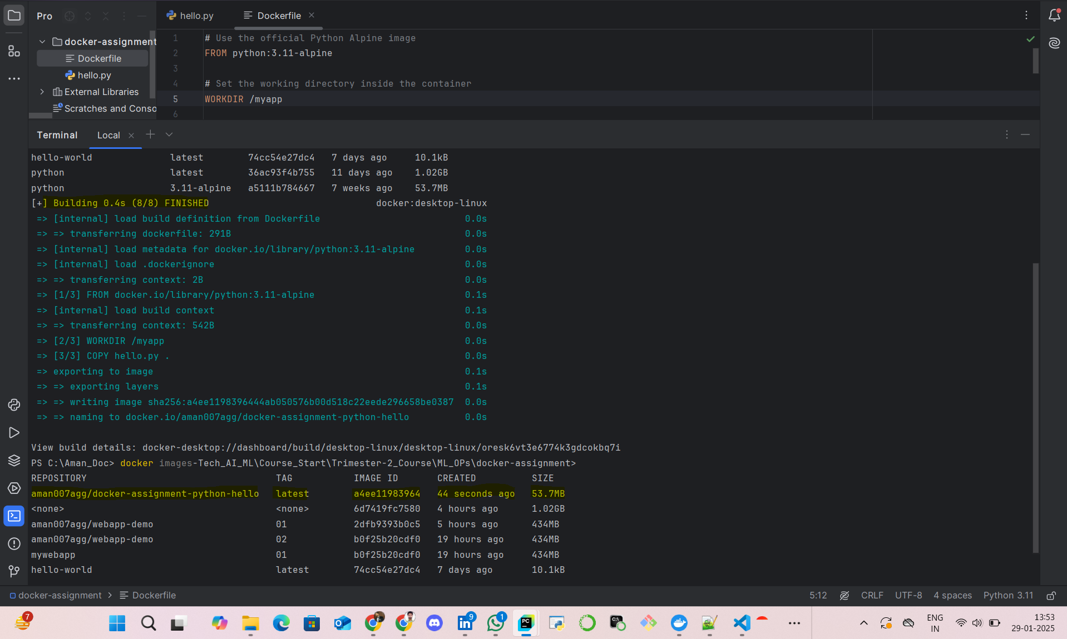

To verify that my image works correctly, I ran:

**docker run --rm aman007agg/docker-assignment-python-hello**

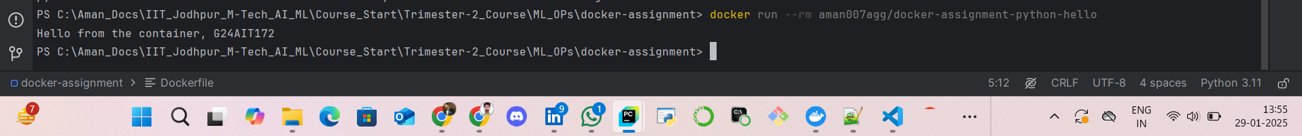  
  
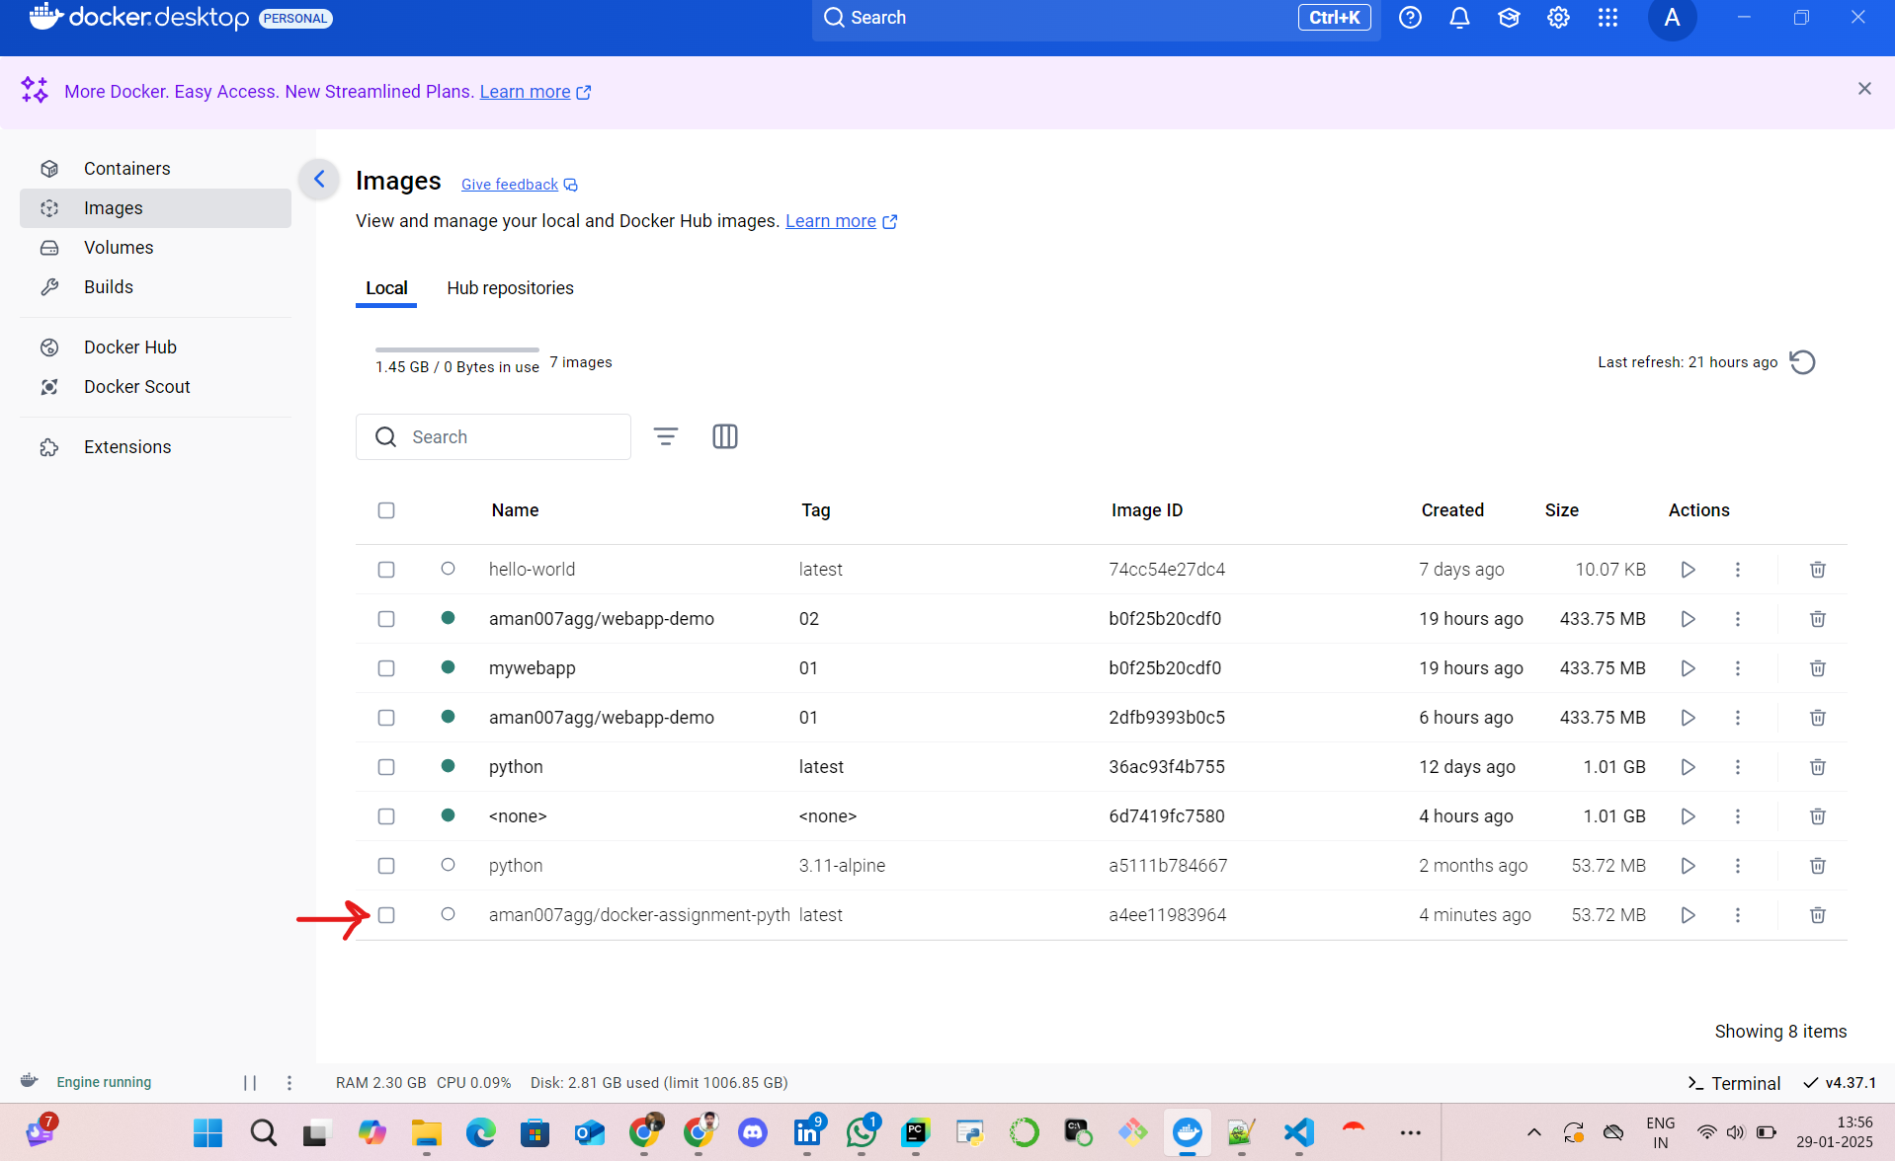

1. **Push the created Docker image to DockerHub. The image should print the above statement when pulled and run. .**

**1. Pushing the Image to Docker Hub**  
First, I logged into Docker Hub using:

**docker login**

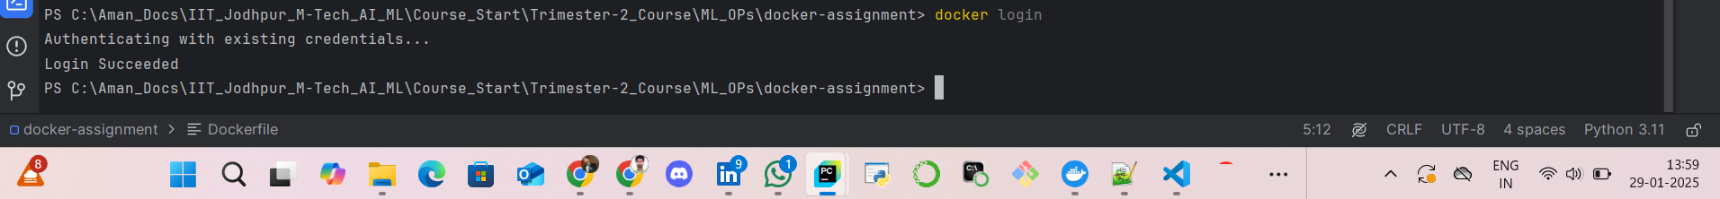  
  
after it gets Authenticated successfully.  
  
I pushed my image to my repository: **aman007agg/docker-assignment-python-hello**

**docker push aman007agg/docker-assignment-python-hello**

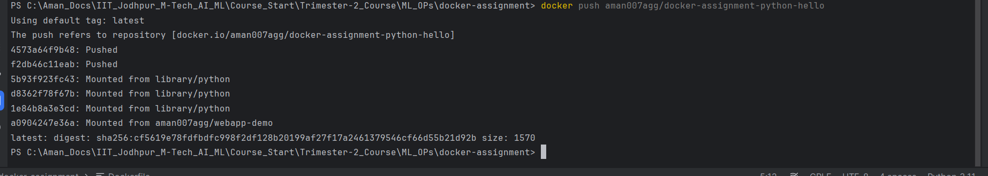

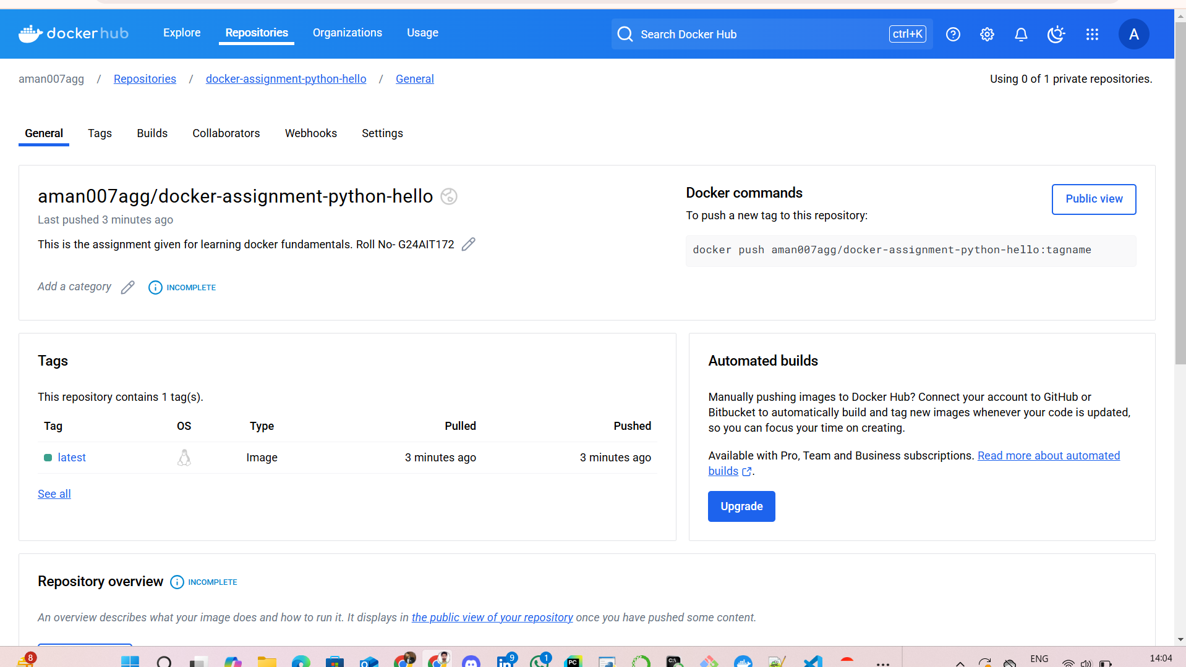  
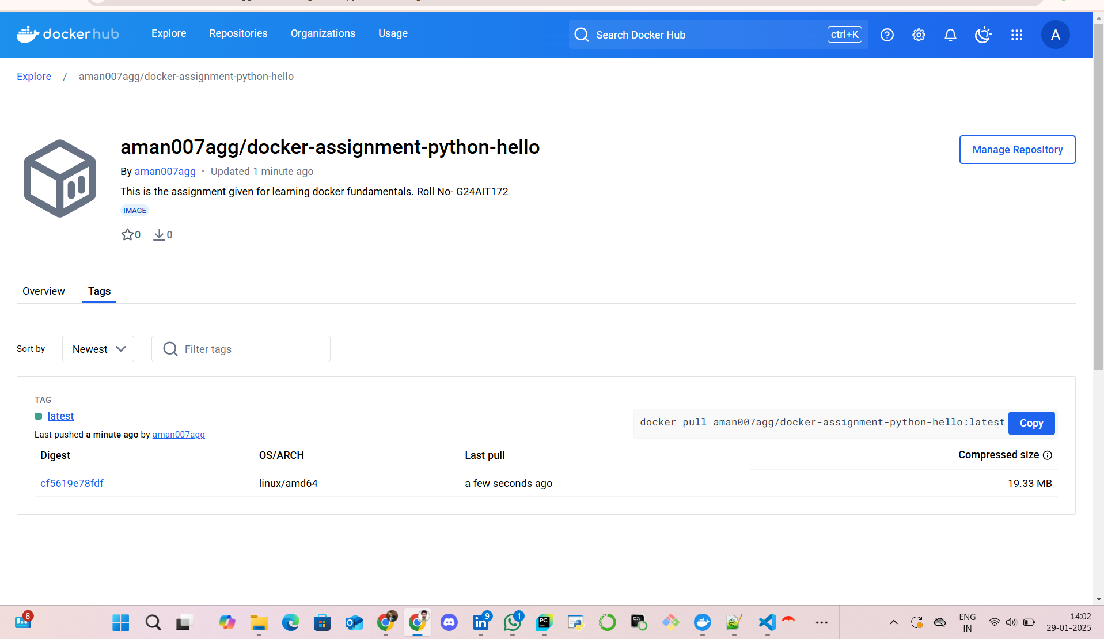  
  
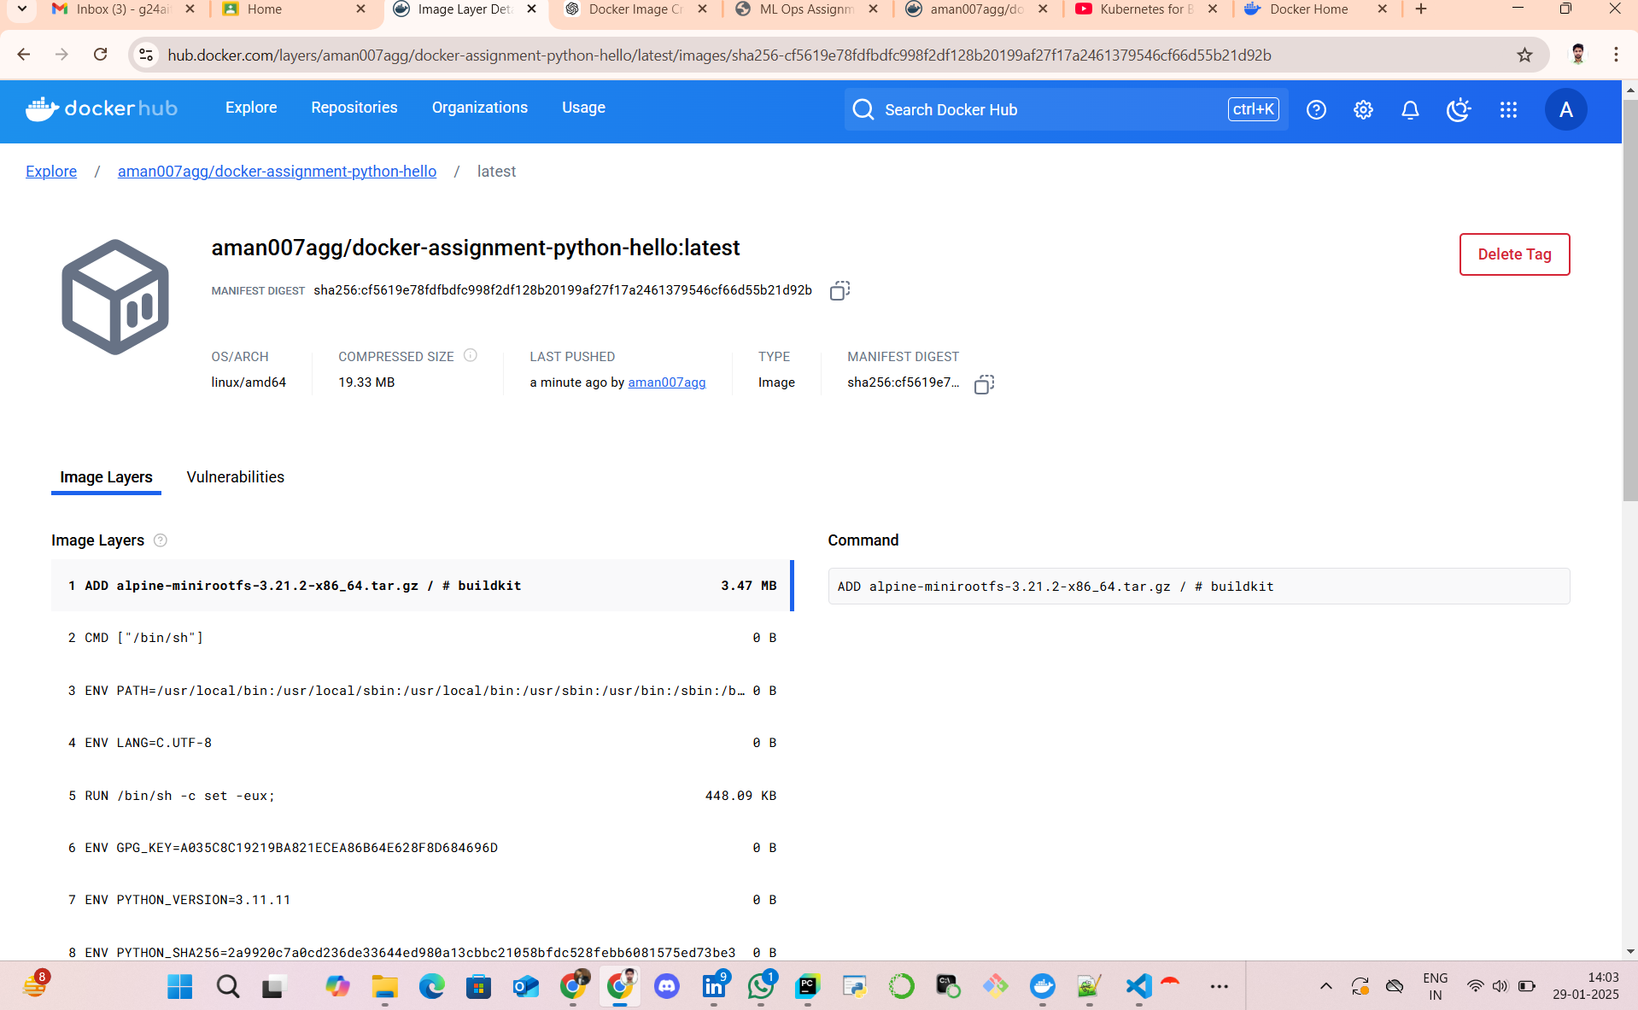

**2. Steps to Pull the Image and Run the Container:**

**docker pull aman007agg/docker-assignment-python-hello**

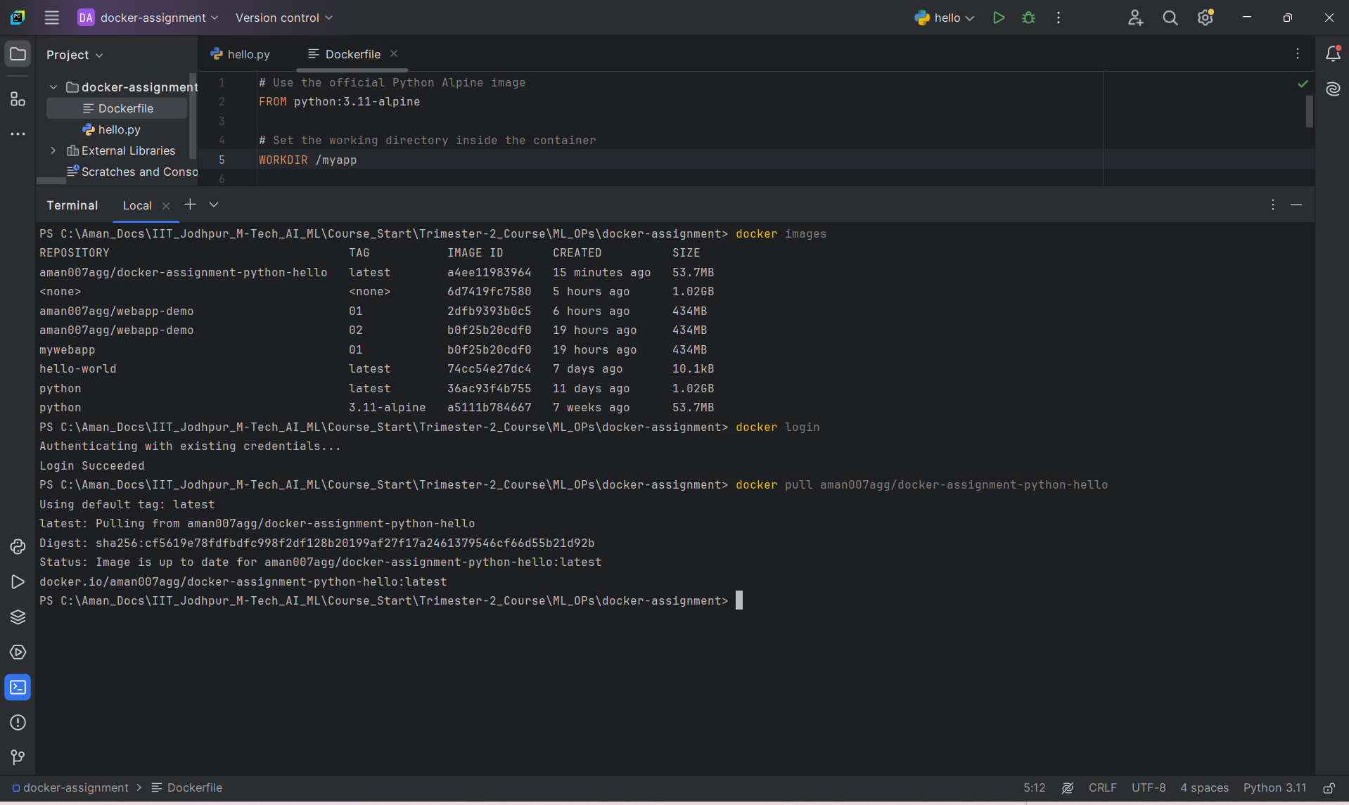

**Run the Container:**  
**docker run aman007agg/docker-assignment-python-hello**

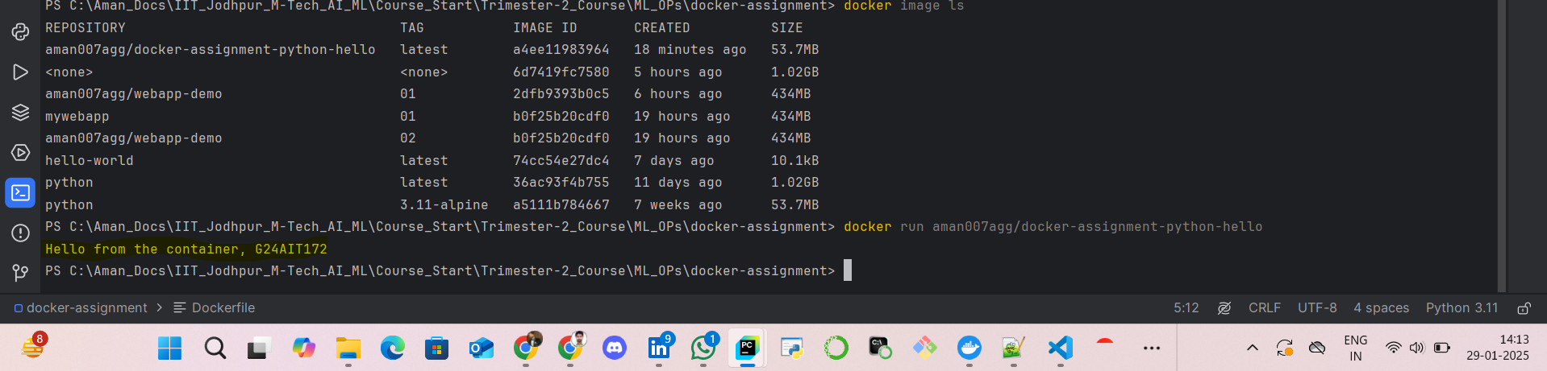

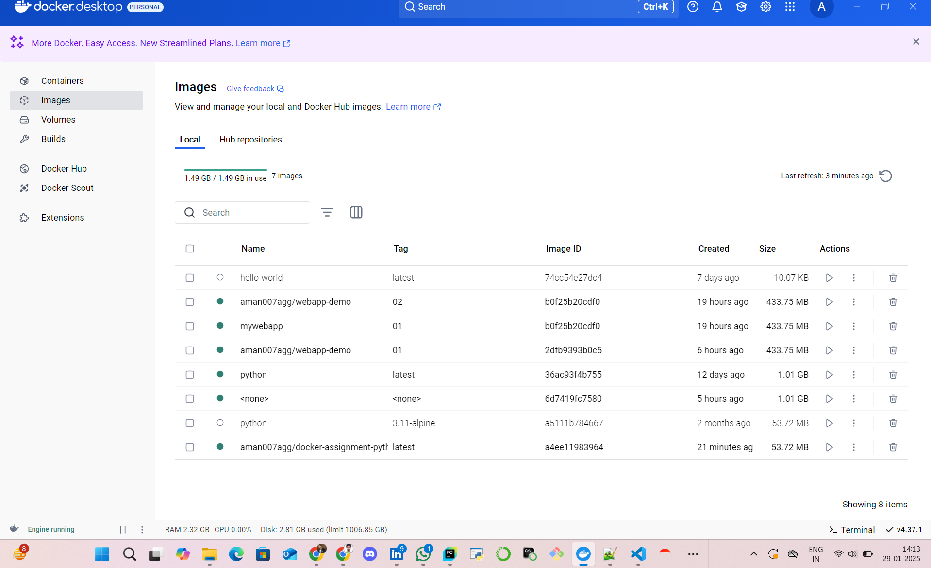  
  
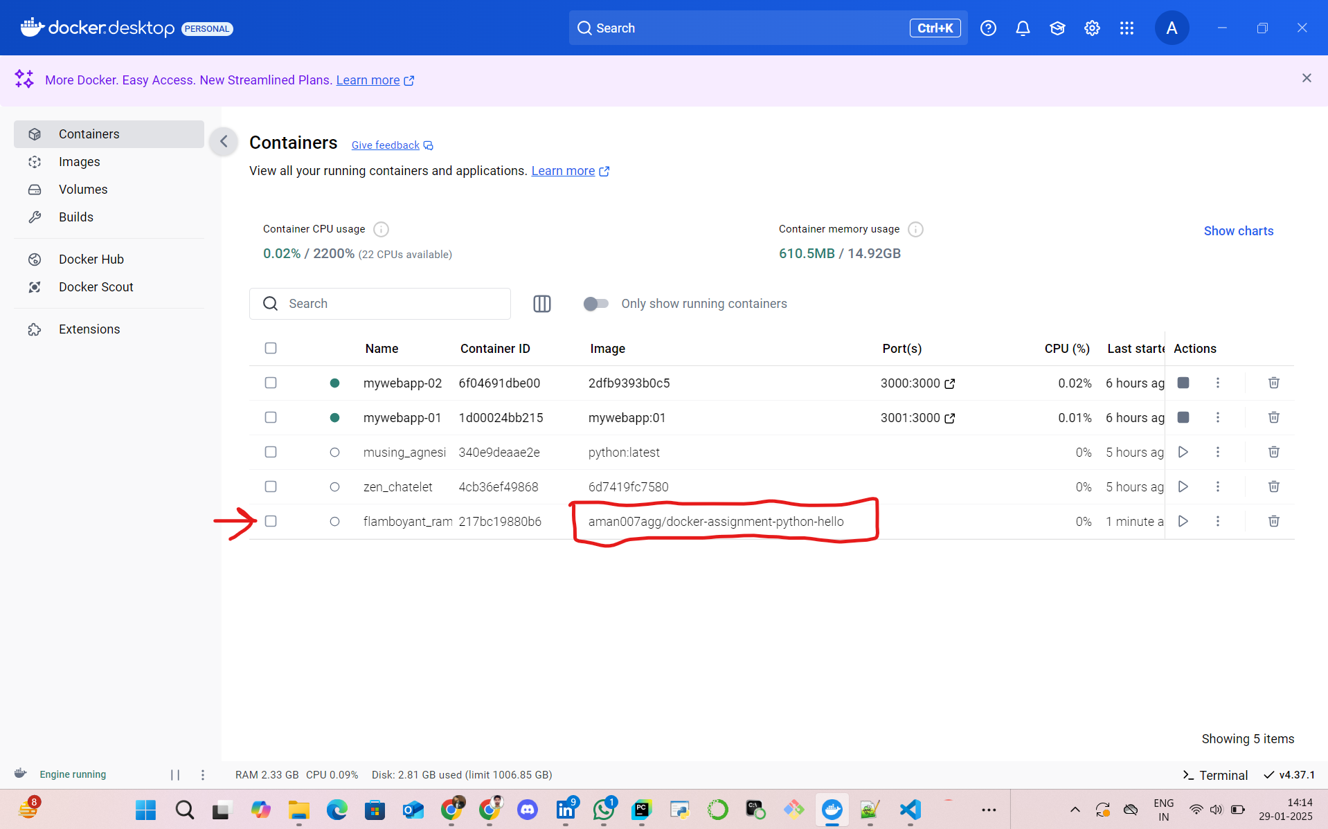  
  
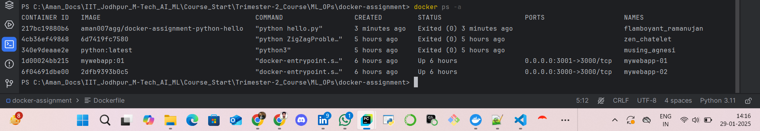

### **4. Conclusion**

This assignment helped me understand the basics of Docker image creation and deployment. I successfully built a custom Docker image, tested it locally, and pushed it to Docker Hub.

Through this process, I became familiar with working with Dockerfile, docker build, docker run, and docker push commands.